Mr. Hood’s private diary
1. Entry, 1st. of summer, 5500

Dear diary,

Great place. Many animals. Much food. Much blood. Can finally be doctor here?... No-talk thrown tantrum today. Stop bossing around. Other confused. Saburo not confused! Saburo born for this moment! Now what?

No-talk good at work, should work! No-talk also ugly. Possibly food?
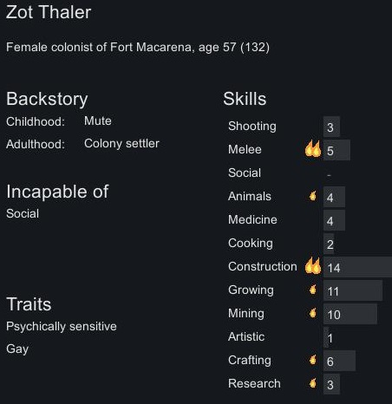



Messy-hair not so much – food later? Messy-hair good food later.

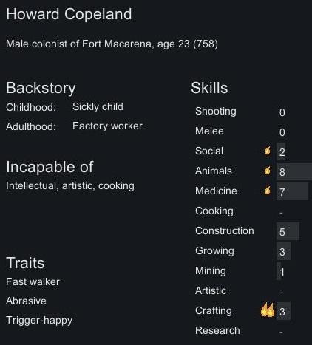

Baker knows guns – usefull! Maybe later food?
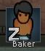
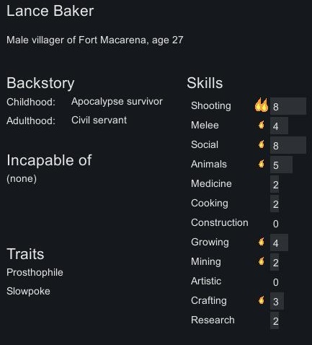

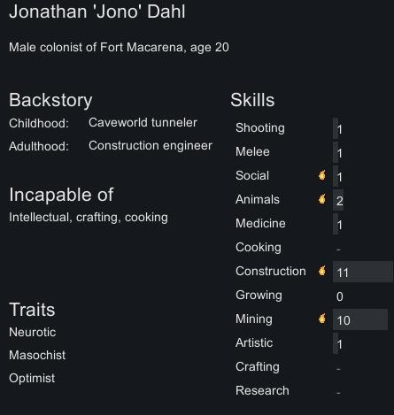

Nakedy-man knows how to dig. Digging is important – Nakedy man important! If necessary food. Yes. Food. Maybe…

Overall place messy. Needs cleaning. Saburo needs hospital Saburo WILL be the greatest doctor on the planet! Soon… Soon Saburo… SOON.

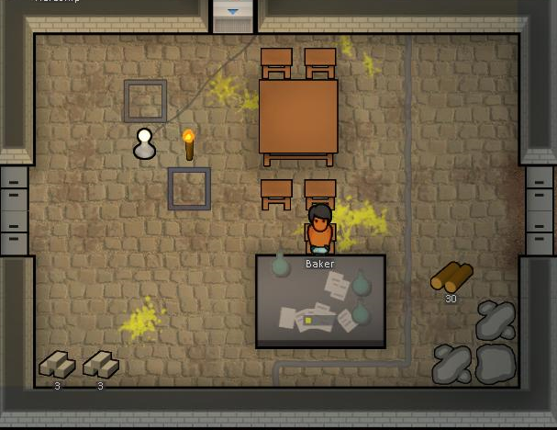
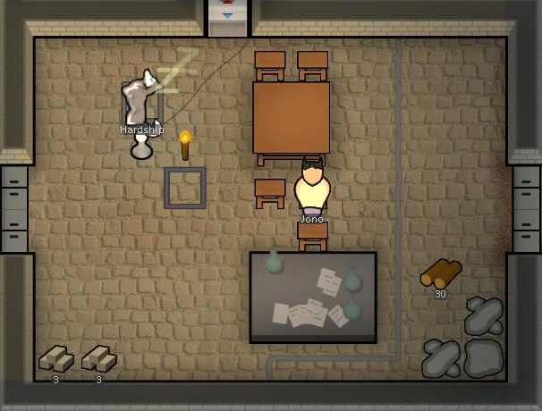
Messy place – everywhere… Need just a mop and few hours! Soon – soon it will be clean again!
Yes! Clean again. Everything clean indeed! Now to sleep!

Mr. Hood’s private diary
1. Entry, 2nd. of summer, 5500

Dear diary,

Saburo thinks – place IS good. Place need work though. Much work. What is needed, Saburo asks himself. And Saburo answers! Hospital, defense, better living conditions fot meat – friends. Yes. All this shall be built soon. Today not a busy day.
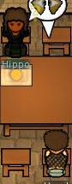
Saburo talks with guests. Guests nice. Guests say planet dangerous. Saburo smiled – where not danger? Danger not in Saburo’s mind – yes… But everywhere else danger. Much danger. Need hospital and defense first – all else must wait.

I like no-talky. She silent. She calm. Saburo like silent, calm people. There is enough voices in Saburo’s head already. Maybe if Saburo eats friends, he’ll eat no-talky last! She nice!

Saburo out for today. Saburo tired. Hard day. Much cleaning in the kitchen. Great day.

Mr. Hood’s private diary
1. Entry, 3rd. of summer, 5500

Dear diary,

today is the day. Nakedy-guy and no-talks started building hospital. Sterile floor, medicine storage – all Saburo needs! Took a while to finish but it nearly done!
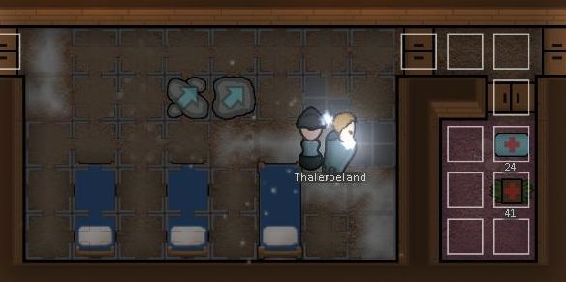
Messy-hair also helps. Hospital right under Saburo’s house. Saburo can quickly enter, quickly help. Saburo likes helping. Also likes blood. Saburo likes butterflies too. They taste so well… So good.

Otherwise also good day. Finished some work on kitchen.

Now Saburo needs to sleep, diary. Saburo works hard. But Saburo happy. Happier than home. Much happier. So much screaming back home. Saburo don’t like screaming.

Mr. Hood’s private diary
1. Entry, 4rd. of summer, 5500

Dear diary,

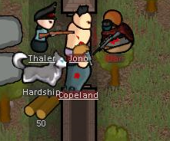
today exciting day! We attacked by pirates. Not many – three pirates. Sniper, pitchofrk and shotgun. Pirater tried to attack from two sides! Nakedy-guy and messy-hair attacked sniper when he tried to enter through eastern gate! Easy work. Saburo watched. Much stabbing, so wow…

After that we run back to village – guests there! Unarmed guests. Saburo excited. Unarmed guests and shotgun-armed pirates? Much work in the hospital! Great day indeed! Battle soon begins…
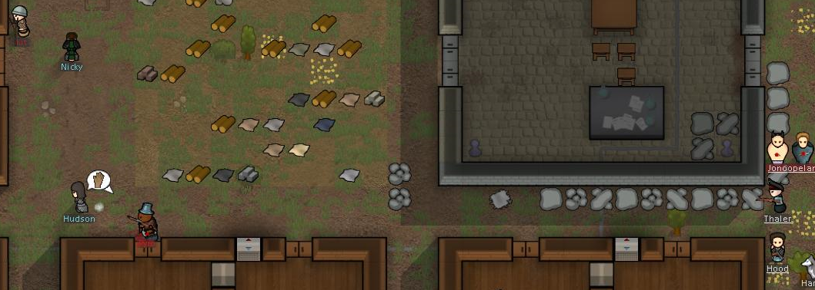
Saburo and no-talks soon takes position. Shotgun charged – had been hit many times! Then he run. Heavily wounded. Saburo would like to help him – or kill him. Booth good… He run though. Second pirate killed – messy-hair and nakedy-guy killed him near workshop. Much blood. But – nobody heavily wounded. Just bruises. We preservered!

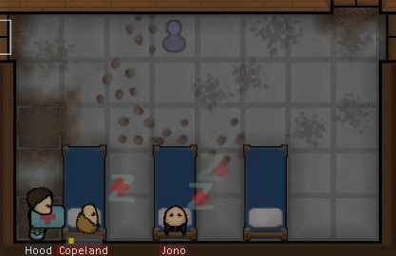
Still Saburo’s first day in the hospital! Saburo used bandages, medicine, lotions – nice work Saburo did! Nice work indeed. Messy-hair looked strange when Saburo applied lotion – Nakedy-guy screamed as Saburo applied desinfection. Saburo doesn’t like screaming. Nakedy guy might need to go soon… Soon…

Mr. Hood’s private diary
1. Entry, 5th. of summer, 5500
Dear diary,

it was very hard day today! So much work done... Tailoring workbench in the workshop! Research table in the workshop – new table and furniture in the common room. Saburo good leader now! Escpecially glad about chairs – new chairs. Back support. Much healthier! Friends need to be healthy! Made pictures too! Colony looking nice now. Soon we live nice.
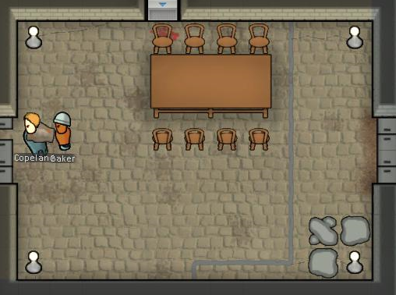
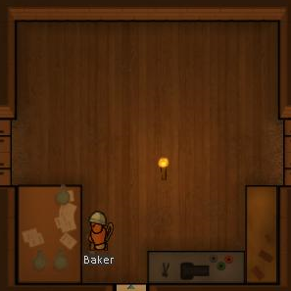

But most importantly, diary, Saburo made hat. Saburo loves hats. Hats are the best things besides silence, blood and no-talk grandma.
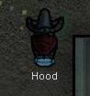
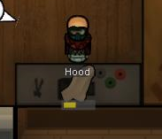
So, diary, great day in the end!

Mr. Hood’s private diary
1. Entry, 6th. of summer, 5500

Dear diary,

as of today there is a toolbox in our village! Will help much with stoneworking and tailoring! Overall calm day. Caravan – nothing usefull. Some cooking. No-talks looks depressed today. Saburo wants to make no-talks happy. So… No talks have new pots with plants. She likes plants. Maybe? Looks like she does. Also – new solar panels. Solar energy endless – Saburo need endless energy for his plans.
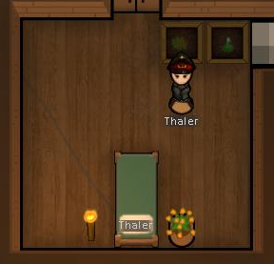
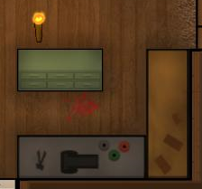
Yes. She seems to like it. Spends a lot of time alone. Saburo hears it over the wall. Saburo always listen. Always.

The workshop is comming along nicely. Still – there is much work to be done here.

Mr. Hood’s private diary
1. Entry, 7th. of summer, 5500
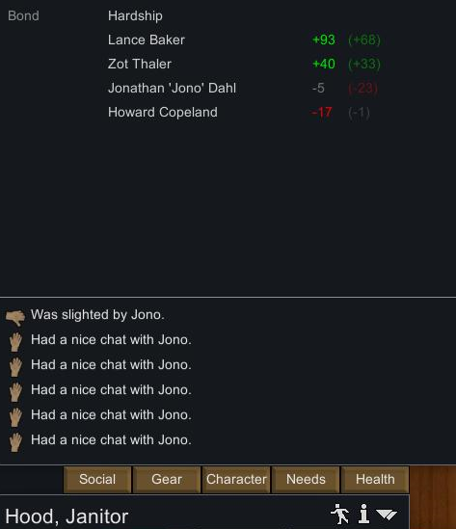
Dear diary,

no-talks seem happier today! So… Saburo happy too. I guess we are good. Maybe she no-food. Baker definitely no-food… Everything goes well. Very warm, calm day today. We had time – so our storage has been built. To store wood, steel, everything we need or will need in future. Saburo thinks that’s all the basics we need.

If somebody reads this diary in the future, Saburo prepared a map of the colony! You should find i tunder this entry. You can see we are defended. Wall is being built, storage in the central part. Kitchen and dining hall in the east. Workshop in the west. All that is important is here now.

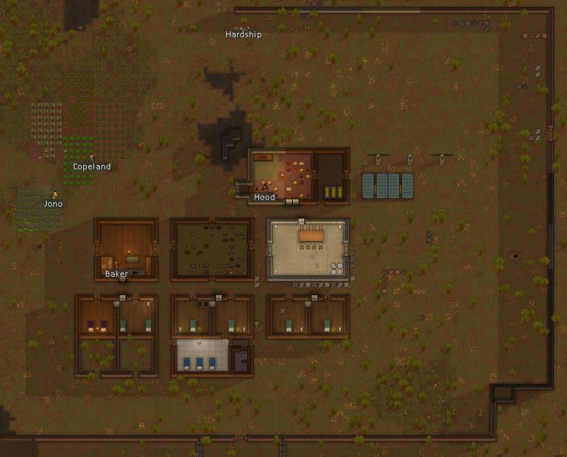
Mr. Hood’s private diary
1. Entry, 8th. of summer, 5500

Dear diary,

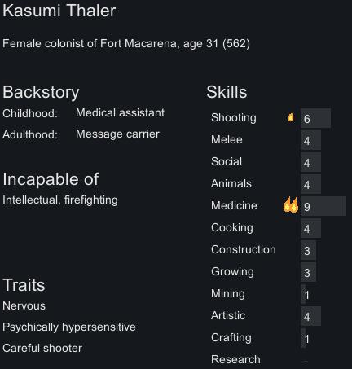
today, radio transmission waked us up. No-talks daughter, Kasumi, was running away from the pirates! I didn’t even know no-talks had a daughter – should pay more attention later on. We set off to save her!

As we went on, no-talks looked anxious. Saburo was sure, we will prevail. We set up an ambush near the northern hill. Waiting for the enemies, everyone looked tense.Saburo’s jokes about internal wounds and infections didn’t find a good audience. Need to lower the dosage of my pills I think. Let’s see.

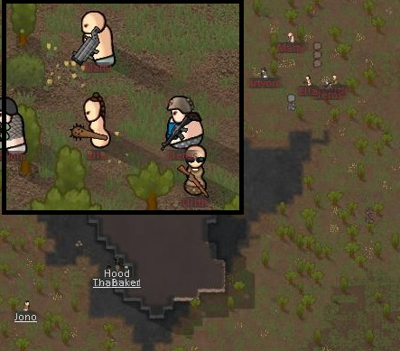
Pirates were well equiped. Saburo was quite unsure in the end! Rocket lounchers cause untreatble injuries. Very often. Saburo wouldn’t beg lad if no-talks or Baker got untreatably injured. Messy hair might attack first maybe? Yes. Messy-hair will attack first!

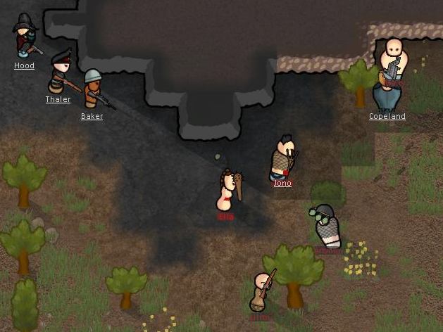
Battle messy. Many bullets flying around, much blot and spilled guts. Messy-hair attacked rocketman – got badly injured with Naked-guy who wasn’t so naked today – rocket went off in the end! Saburo, No-talks and Baker shot few pirates from the bad.

Some pirates tried to run – they did. But no-talks wounded them pretty badly with a rifle. Saburo admired no-talks now!

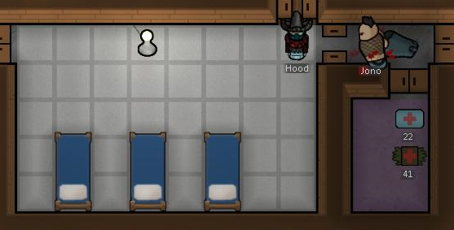
Messy-hair heavily injured. Right leg almost gone! Many shranpnels in whole body. Hard work for Sabur that day. Many hours in the hospital, very tired – but messy-hair will live for now. Leg saved! Nakedy-guy also fine in the end.

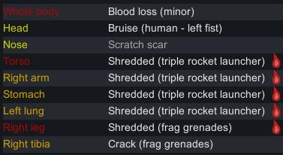
Saburo thinks Kasumi good. She also knows medicine. Maybe Kasumi and Saburo friends? In the future? Saburo likes people who talks about guts, intestines and blood. All good thinks, no? No? Anyway – good night, diary. Much blood on my hands today, much sweat on my forehead.

Mr. Hood’s private diary
1. Entry, 11th. of summer, 5500

Dear diary,

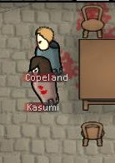
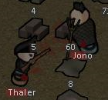
last days hard. Too much screaming everywhere. No-talks punched naked guy… Kasumi punched messy-hair – too much screaming. Saburo tried to hide – calm everyone. Not possible. Not possible – new solution! With no-talks, we had built pool table and chess! Maybe now less screaming, more playing? Our prisoner is doing quiiiiite well. He talks, isn’t infected. Might join us soon?

Also Saburo started new work schedule. Only doctor work, cooking and research now! Baker tired of research – not good at it. Saburo doesn’t like inventions but still – best one for the job!
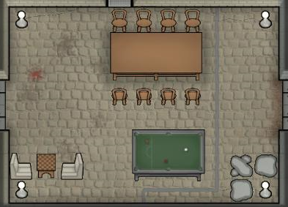
Saburo happy – except for the screaming. Enough food, joy, energy, much work to do – Saburo LOVES work. Especially when it’s a lot of work. Work that needs to be done fast. Great place.

And that would be all for today, diary!

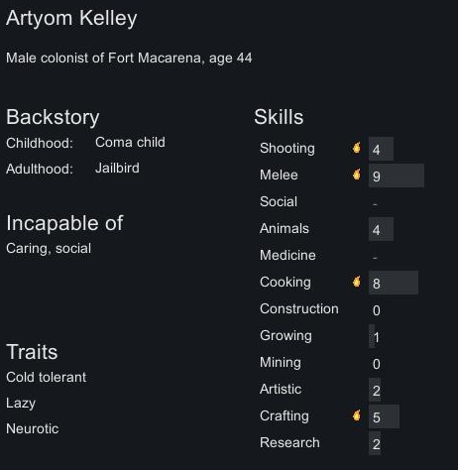
Mr. Hood’s private diary
1. Entry, 12th. of summer, 5500

Dear diary,

today our prisoner joined us! He’s quick like Saburo! But – lazy a bit. Saburo doesn’t like lazy people. Lazy people strange. Saburo doesn’t like strange people… Strange, twitchy people… People who can’t say one sentence right. No – Saburo doesn’t like that!
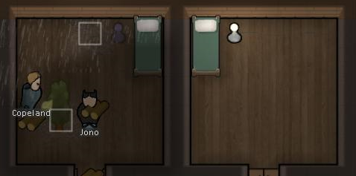
He and Kasumi neighbors now. New houses will be done tomorrow. Good time!

And Saburo finished important research – microelectronics!

Mr. Hood’s private diary
1. Entry, 15th. of summer, 5500

Dear diary,

it was nice to lead a village for a while. Saburo did well. New housing, fields, many resources in the storage, enough food, hospital, joy and beautifull dining hall. Also research started to go quicker. Saburo is quite proud. Homewer Saburo CAN’T continue! People always screaming, yelling, speaking aloud – Saburo doesn’t like that! Everyone comming to Saburo for advice or orders – Saburo doesn’t like talking THIS much. So in the end – I am going to step off. Saburo i salso interested in who will succeed him! Saburo hope that research and medicine will be his jobs in the future. Funny jobs – you know… Yes, people scream sometimes, but only until Saburo make them sleep. Saburo like to make people sleep – but back to the topic.

Wall around the village is complete, we have enough resources – best of luck to Saburo’s successor! I am adding a map of the village.



